**Statistik Deskriptif**

|  |  |  |  |  |  |
| --- | --- | --- | --- | --- | --- |
| **Descriptive Statistics** | | | | | |
|  | N | Minimum | Maximum | Mean | Std. Deviation |
| ROE | 90 | -136.44 | 1.55 | -1.5530 | 14.38460 |
| QR | 90 | .07 | 3.46 | .8613 | .73063 |
| DER | 90 | -7.18 | 786.93 | 11.9244 | 83.31041 |
| ZSCORE1 | 79 | -4.51 | 1.79 | .4453 | .95750 |
| Valid N (listwise) | 79 |  |  |  |  |

**Pengaruh Return on Equity (ROE) terhadap Indeks Z-Score**

|  |  |  |  |  |
| --- | --- | --- | --- | --- |
| **Model Summary** | | | | |
| Model | R | R Square | Adjusted R Square | Std. Error of the Estimate |
| 1 | .131a | .017 | .005 | .95534 |
| a. Predictors: (Constant), ROE | | | | |

|  |  |  |  |  |  |  |
| --- | --- | --- | --- | --- | --- | --- |
| **ANOVAa** | | | | | | |
| Model | | Sum of Squares | Df | Mean Square | F | Sig. |
| 1 | Regression | 1.236 | 1 | 1.236 | 1.354 | .248b |
| Residual | 70.275 | 77 | .913 |  |  |
| Total | 71.511 | 78 |  |  |  |
| a. Dependent Variable: ZSCORE1 | | | | | | |
| b. Predictors: (Constant), ROE | | | | | | |

|  |  |  |  |  |  |  |
| --- | --- | --- | --- | --- | --- | --- |
| **Coefficientsa** | | | | | | |
| Model | | Unstandardized Coefficients | | Standardized Coefficients | t | Sig. |
| B | Std. Error | Beta |
| 1 | (Constant) | .460 | .108 |  | 4.250 | .000 |
| ROE | .008 | .007 | .131 | 1.164 | .248 |
| a. Dependent Variable: ZSCORE1 | | | | | | |

**Pengaruh Quick Ratio (QR) terhadap Indeks Z-Score**

|  |  |  |  |  |
| --- | --- | --- | --- | --- |
| **Model Summary** | | | | |
| Model | R | R Square | Adjusted R Square | Std. Error of the Estimate |
| 1 | .342a | .117 | .106 | .90548 |
| a. Predictors: (Constant), QR | | | | |

|  |  |  |  |  |  |  |
| --- | --- | --- | --- | --- | --- | --- |
| **ANOVAa** | | | | | | |
| Model | | Sum of Squares | Df | Mean Square | F | Sig. |
| 1 | Regression | 8.379 | 1 | 8.379 | 10.220 | .002b |
| Residual | 63.132 | 77 | .820 |  |  |
| Total | 71.511 | 78 |  |  |  |
| a. Dependent Variable: ZSCORE1 | | | | | | |
| b. Predictors: (Constant), QR | | | | | | |

|  |  |  |  |  |  |  |
| --- | --- | --- | --- | --- | --- | --- |
| **Coefficientsa** | | | | | | |
| Model | | Unstandardized Coefficients | | Standardized Coefficients | t | Sig. |
| B | Std. Error | Beta |
| 1 | (Constant) | .026 | .166 |  | .159 | .874 |
| QR | .444 | .139 | .342 | 3.197 | .002 |
| a. Dependent Variable: ZSCORE1 | | | | | | |

**Pengaruh Debt to Equity Ratio (DER) terhadap Indeks Z-Score**

|  |  |  |  |  |
| --- | --- | --- | --- | --- |
| **Model Summary** | | | | |
| Model | R | R Square | Adjusted R Square | Std. Error of the Estimate |
| 1 | .135a | .018 | .006 | .95485 |
| a. Predictors: (Constant), DER | | | | |

|  |  |  |  |  |  |  |
| --- | --- | --- | --- | --- | --- | --- |
| **ANOVAa** | | | | | | |
| Model | | Sum of Squares | Df | Mean Square | F | Sig. |
| 1 | Regression | 1.307 | 1 | 1.307 | 1.434 | .235b |
| Residual | 70.204 | 77 | .912 |  |  |
| Total | 71.511 | 78 |  |  |  |
| a. Dependent Variable: ZSCORE1 | | | | | | |
| b. Predictors: (Constant), DER | | | | | | |

|  |  |  |  |  |  |  |
| --- | --- | --- | --- | --- | --- | --- |
| **Coefficientsa** | | | | | | |
| Model | | Unstandardized Coefficients | | Standardized Coefficients | t | Sig. |
| B | Std. Error | Beta |
| 1 | (Constant) | .463 | .108 |  | 4.268 | .000 |
| DER | -.001 | .001 | -.135 | -1.197 | .235 |
| a. Dependent Variable: ZSCORE1 | | | | | | |

**Pengaruh Simultan ROE, QR dan DER terhadap Indeks Z-Score**

|  |  |  |  |  |  |
| --- | --- | --- | --- | --- | --- |
| **Model Summaryb** | | | | | |
| Model | R | R Square | Adjusted R Square | Std. Error of the Estimate | Durbin-Watson |
| 1 | .355a | .126 | .091 | .91290 | 1.330 |
| a. Predictors: (Constant), DER, QR, ROE | | | | | |
| b. Dependent Variable: ZSCORE1 | | | | | |

|  |  |  |  |  |  |  |
| --- | --- | --- | --- | --- | --- | --- |
| **ANOVAa** | | | | | | |
| Model | | Sum of Squares | Df | Mean Square | F | Sig. |
| 1 | Regression | 9.007 | 3 | 3.002 | 3.603 | .017b |
| Residual | 62.504 | 75 | .833 |  |  |
| Total | 71.511 | 78 |  |  |  |
| a. Dependent Variable: ZSCORE1 | | | | | | |
| b. Predictors: (Constant), DER, QR, ROE | | | | | | |

|  |  |  |  |  |  |  |  |  |
| --- | --- | --- | --- | --- | --- | --- | --- | --- |
| **Coefficientsa** | | | | | | | | |
| Model | | Unstandardized Coefficients | | Standardized Coefficients | t | Sig. | Collinearity Statistics | |
| B | Std. Error | Beta | Tolerance | VIF |
| 1 | (Constant) | .052 | .200 |  | .260 | .795 |  |  |
| ROE | .002 | .208 | .027 | .008 | .994 | .001 | 957.958 |
| QR | .429 | .149 | .331 | 2.874 | .005 | .879 | 1.138 |
| DER | -.001 | .036 | -.068 | -.020 | .984 | .001 | 960.524 |
| a. Dependent Variable: ZSCORE1 | | | | | | | | |

**Charts**

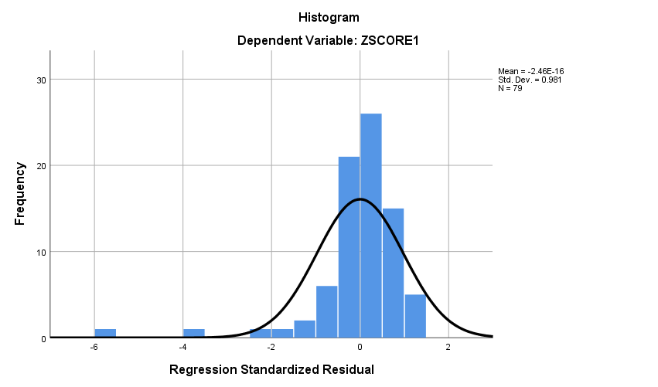

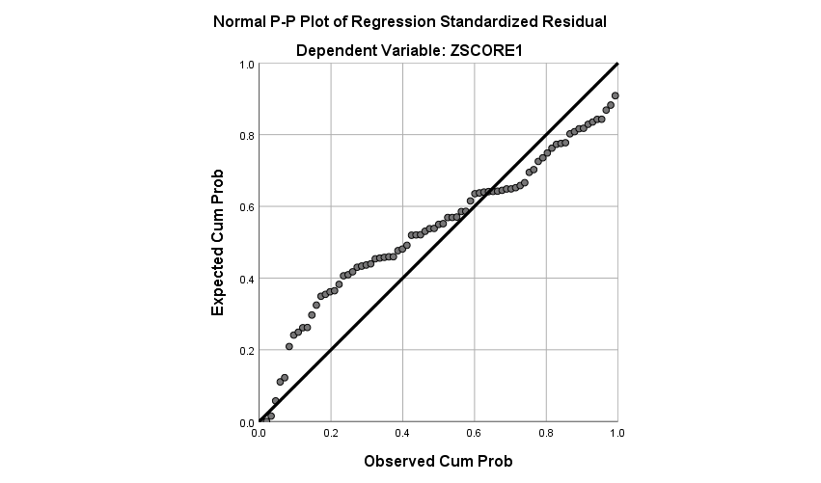

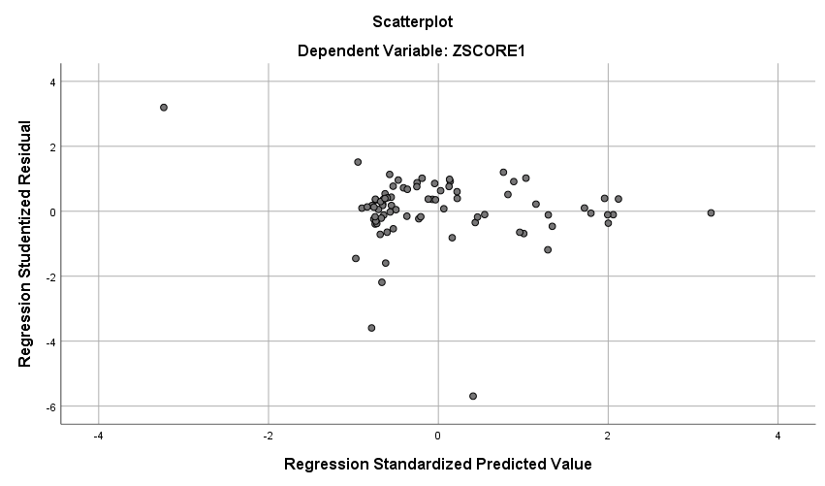

**NPar Tests**

|  |  |  |
| --- | --- | --- |
| **One-Sample Kolmogorov-Smirnov Test** | | |
|  | | Unstandardized Residual |
| N | | 79 |
| Normal Parametersa,b | Mean | .0000000 |
| Std. Deviation | .89516998 |
| Most Extreme Differences | Absolute | .182 |
| Positive | .114 |
| Negative | -.182 |
| Test Statistic | | .182 |
| Asymp. Sig. (2-tailed) | | .000c |
| a. Test distribution is Normal. | | |
| b. Calculated from data. | | |
| c. Lilliefors Significance Correction. | | |